1.
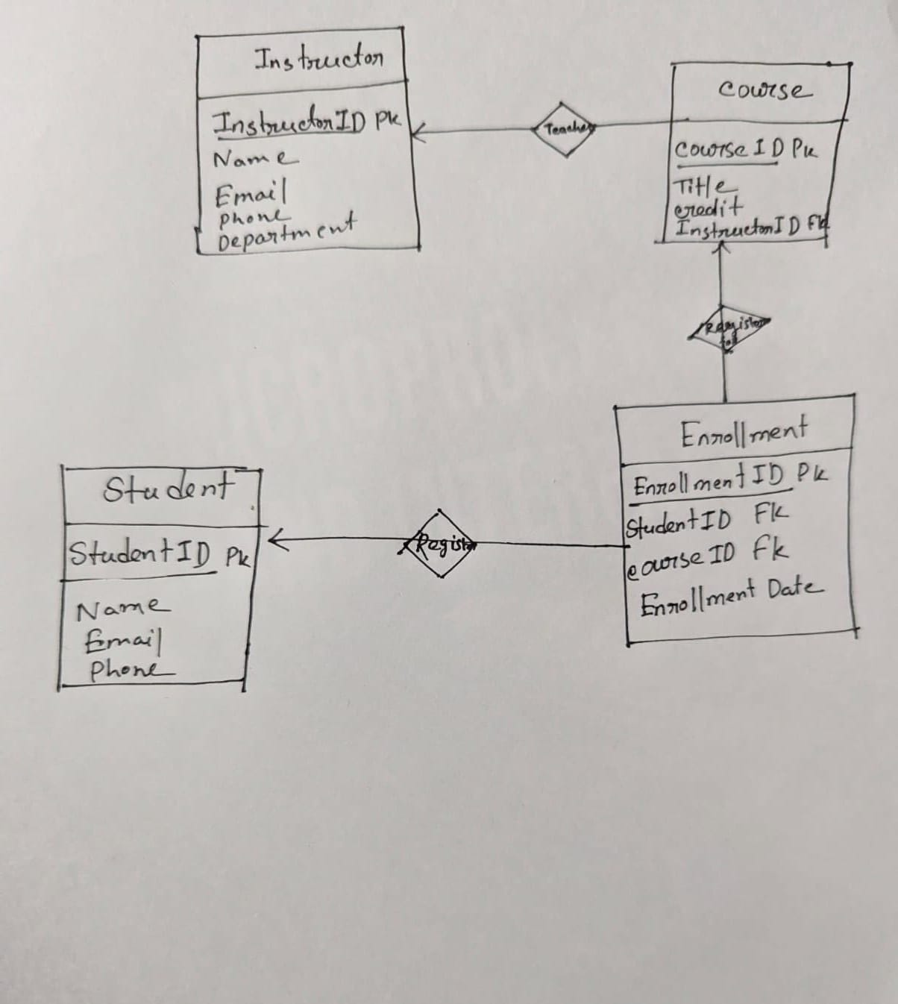

2.
INSERT INTO Enrollment (StudentID, CourseID, EnrollmentDate)
VALUES (5,
(SELECT CourseID FROM Course ORDER BY Credits DESC LIMIT 1),
CURDATE());

3.
UPDATE Course
SET InstructorID = 7
WHERE CourseID = 3;

4.
SELECT I.Name, SUM(C.Credits) AS TotalCredits
FROM Instructor I
JOIN Course C ON I.InstructorID = C.InstructorID
GROUP BY I.InstructorID
HAVING TotalCredits = (
SELECT MAX(TotalCredits)
FROM (
SELECT InstructorID, SUM(Credits) AS TotalCredits
FROM Course
GROUP BY InstructorID
) AS Temp
);

5.
SELECT S.Name, COUNT(E.CourseID) AS TotalCourses
FROM Student S
JOIN Enrollment E ON S.StudentID = E.StudentID
GROUP BY S.StudentID
HAVING COUNT(E.CourseID) > 2;

6.
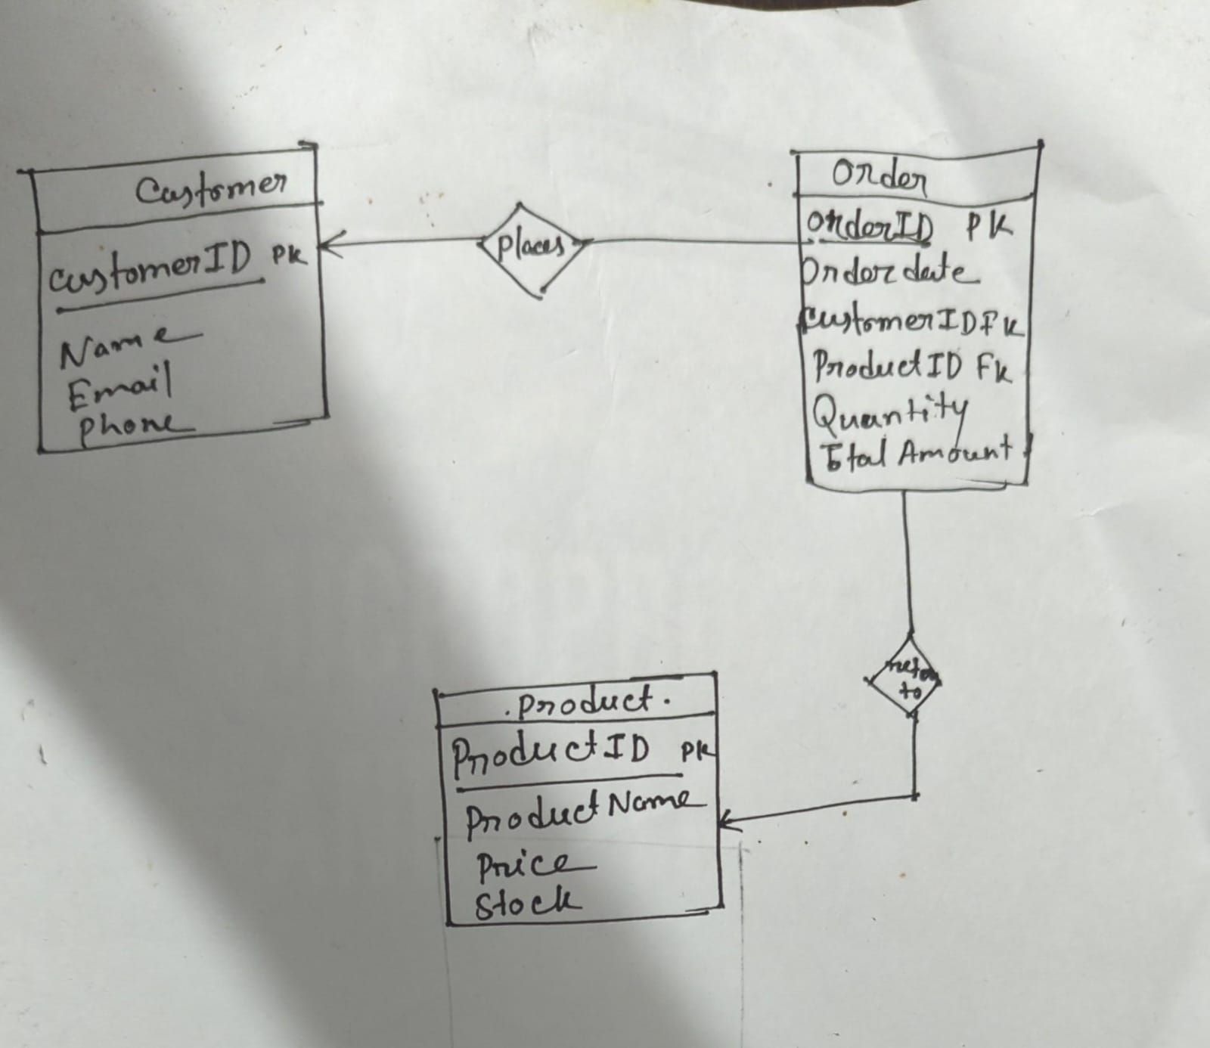

7.

GROUP BY | ORDER BY
Used to group rows having similar values | Used to sort rows (ascending/descending)
Often used with aggregate functions (SUM, COUNT, AVG) | Does not require aggregate functions
Output reduces number of rows | Output shows all rows

Example of GROUP BY
SELECT Department, COUNT(*) AS TotalEmployees
FROM Employee
GROUP BY Department;

Example of ORDER BY
SELECT Name, Salary
FROM Employee
ORDER BY Salary DESC;

8.
SELECT Salary AS SecondHighestSalary
FROM Instructor
ORDER BY Salary DESC
LIMIT 1 OFFSET 1;

9.
CREATE TABLE Instructor (
InstructorID INT PRIMARY KEY,
Name VARCHAR(100)
);

CREATE TABLE Course (
CourseID INT PRIMARY KEY,
CourseName VARCHAR(100),
InstructorID INT,
FOREIGN KEY (InstructorID)
REFERENCES Instructor(InstructorID)
ON DELETE CASCADE
);

10.
The most challenging topic I encountered in this course was Common Table Expressions (CTE) using with as. Initially, it was difficult to understand how a temporary result set could be defined and then referenced multiple times in a query. Writing recursive CTEs, especially for hierarchical data, was even more confusing. I overcame this challenge by practicing simple examples first, breaking queries into smaller steps, and visualizing the intermediate results of the CTE. Gradually, I became comfortable using CTEs for cleaner and more modular SQL queries.

